Benchmark Assessment #2 Review Packet
Directions: Please complete the following as a review for your test on Thursday. This packet will be due before you take the test!
7.E.1.6 Human Impact
1. Name the three fossil fuels. What is an advantage of using fossil fuels?

2. Name three types of renewable resources. Name one advantage and one disadvantage to using renewable resources over fossil fuels.

3. Smog contains water vapor, sulfur dioxide, ammonia, and nitrogen oxide. Which of these do humans have the least control over?

4. Which is more harmful to humans, atmospheric ozone or ground level ozone?

5. What is one cause of ozone layer depletion in our atmosphere?

6. What has happened to carbon dioxide levels in our atmosphere over the last decade? Why is this harmful to the planet?

7.P.1.1- 7.P.1.2
1. What is needed in order to describe a change in position of an object?

2. Imagine you are in a parked car. The car next to you backs out. In which direction does your car seem to be going?
3. Of the following, which one can be described as a good reference point to determine the motion of a vehicle?
a. a woman riding a bike
b. a passenger in the car
c. a stop sign
4. You are pushing on a desk with 10 Newtons of force and the desk does not move. How many Newtons is the desk pushing on your hands?
5. You are running errands with your mom when the car runs out of gas. The car eventually comes to a stop. Which force causes the car to stop?

6. You are in your friend’s car when the car suddenly slams into a tree. You lurch forward with 85 Newtons of force. What force does the seat belt apply back to you? What is the direction of this force?

7. You are playing tug of war with your classmates. Who will win this battle?
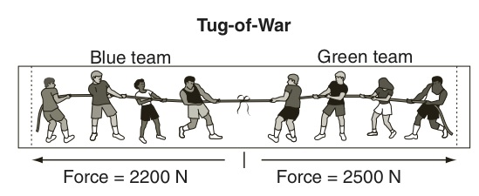
8. In our demonstration, why did the crumpled piece of paper fall more quickly than the flat sheet of paper?

9. Why would a leaf fall more slowly than a quarter when dropped from the same height?

10. Define mass and weight. Of mass and weight, which one is affected by gravity?

11. How does friction affect an object’s movement? In other words, does it increase the movement or does it oppose movement?

12. If a book is sitting on your desk, are the forces on the book and desk balanced or unbalanced?

13. In which direction will object move in the below example?
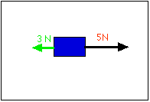
14. As a meteor falls and gets closer to Earth, it encounters a resistance force. Which force must the resistance force overcome in order for the meteor to hit the Earth?

15. Give the net force for the following. Make sure to indicate direction.
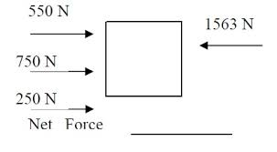
16. Which of the following does NOT describe motion?
a. the car is traveling Northwest
b. the car is bright red
c. the car is passing a V6 mustang
d. the car is traveling 80 mph

Benchmark Review Part 2
7.P.1.3-1.4
Answer the following questions using the graph below:
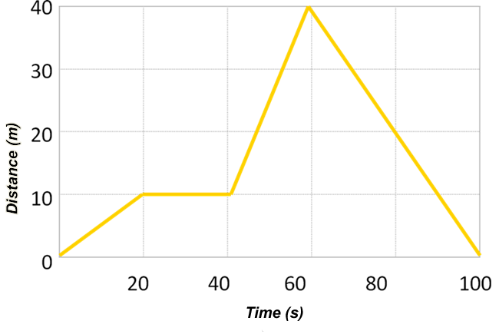

- What is the object’s speed between 0-20 seconds?

- What is the object’s speed between 40-60 seconds?

- What is the object’s speed between 60-100 seconds?

- At what time is the object stationary (not moving)?

- What is the total distance the object traveled?

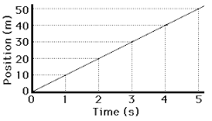
- How far will the object go in 7 s if the object continues to move at the same speed?
Answer the following questions using the graph below:
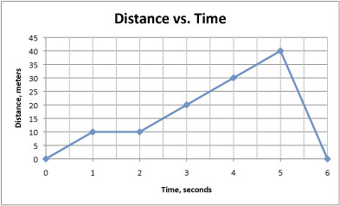

- What is the total distance the object travels?

- What is the average speed of the object from start to finish?

- What is the speed of the object between 2-5 seconds?

- At which point does the object stop and rest?

- What is the speed of the object between 5-6 seconds?

- What is the object’s average speed from 0-4 seconds?

- What is object’s average speed from 4-6 seconds?

Answer the following using the graphs below:
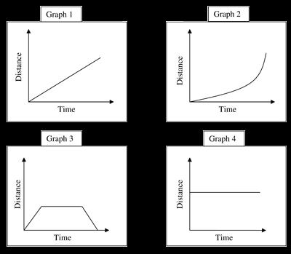

- Which graph show no motion?

- Which graph shows an object returning to start?

- Which graph shows constant motion?

- Which graph shows an object speeding up?

