Name: _____________________
Date: ________________
Cell Parts
Directions: Read the article then fill in the blanks in the sentences at the end of the article.
Cells are the tiny building blocks of living things. Each cell has a part called a cell membrane; a thin covering around the cell. The cell membrane separates the inside parts of the cell from the outside environment, gives the cell its shape, and controls what goes into and out of it. Located inside a cell is the cytoplasm. Cytoplasm is a jellylike liquid. Inside the cytoplasm is the cell's control center called the nucleus. The nucleus contains all of the instructions for running the cell. The nucleus is surrounded by the nuclear membrane. The nuclear membrane controls what goes into and comes out of the nucleus.
A cell is able to reproduce by means of splitting. One cell splits into two cells. However before the cell splits, the nucleus doubles and divides in half so each new cell has a copy of the cell's instructions.
Look carefully at the diagram of the cell below. Notice inside the cytoplasm are vacuoles and mitochondria. Vacuoles are tiny oval structures that store food, water, or wastes. Mitochondria are shaped like kidney beans. Mitochondria are important parts of a cell because they help change food into energy. The cell uses the energy to do its work.
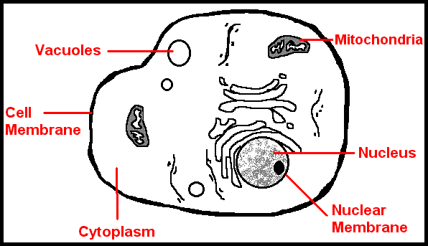
Cells do not all look the same. Their shape depends upon the jobs they perform. Red blood cells are tiny and round. They need to be so they can squeeze through blood vessels and bring oxygen to the other cells in the body. Muscle cells are thin and long. This is so they can expand and contract to help the body move.
All cells, whether plant or animal have these same parts: cell membrane, cytoplasm, nucleus, nuclear membrane, vacuoles, and mitochondria. Plant cells however have two additional parts that animal cells do not. Plant cells have cell walls. This sturdy layer around the cell membrane supports and protects the cell. Plant cells also contain chloroplasts. Chloroplasts contain the green substance called chlorophyll. Chlorophyll traps energy from sunlight and enables a plant to make its own food.
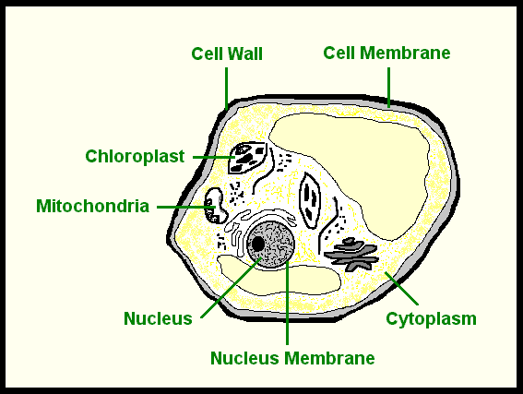
Directions: Answer the questions about cells and their parts.
1. Located inside each cell is a jellylike liquid called _______________________.
2. The control center of a cell is the__________________________.
3. The thin covering around a cell is called the cell _____________________.
4. Cells reproduce by ________________________ .
5. Vacuoles are tiny _______________shaped structures that store food, water, or wastes.
6. Mitochondria, the kidney bean shaped part of a cell, help change food into ____________.
7. Red ____________ cells are a tiny, round shape.
8. ___________________ cells are a thin and long.
9. _________________ cells have two additional parts that animal cells do not.
10. Plant cells contain chloroplasts which contain the green substance called_______________.

