What is a Jet Stream?
Kim Ann Zimmermann, LiveScience Contributor

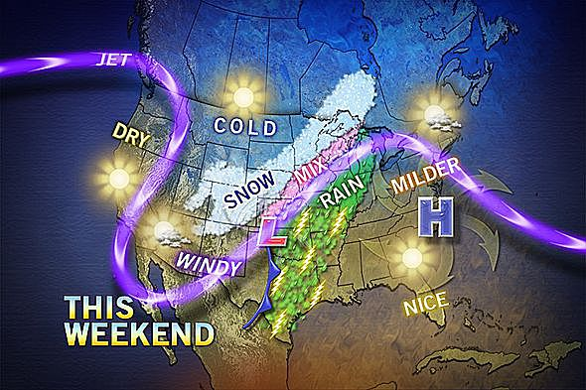
The jet stream, in purple, separates cold air over the Rocky Mountains from warm air over the Midwest in this forecast map for the weekend of March 8, 2013.
What are Jet Streams?
Jet streams are like rivers of wind high above in the atmosphere. These slim strips of strong winds have a huge influence on climate, as they can push air masses around and affect weather patterns.

Where are Jet Streams?
The jet streams on Earth typically run from west to east. They are narrow and long. Jet streams are typically active at 20,000 feet to 50,000 feet or about 7 miles above the surface. They travel in the troposphere of Earth’s atmosphere. They often travel a very winding path. They can fade away or break off into smaller “rivers” of air that merge again “downstream.”
Both the Northern and Southern hemispheres have jet streams. The jet streams in the north are more forceful. Each hemisphere has two primary jet streams, a polar and a subtropical. The polar jet streams form between the latitudes of 50 and 60 degrees north and south of the equator. The subtropical jet stream is closer to the equator and forms at the latitudes of 20 to 30 degrees.

What factors affect the Jet Streams?
Jet streams are affect by the seasons of the year, location of low and high pressure and air temperature. Jet streams form a border between hot and cold air. Because air temperature influences jet streams, they are more active in the winter when there are wider ranges of temperatures between the competing Arctic and tropic air masses.
Temperature also changes the velocity of the jet stream. The greater the difference in air temperature, the faster the jet stream flows. Jet streams can reach speeds of up to 250 mph (402 kph) or greater, but average about 110 mph (177 kph).
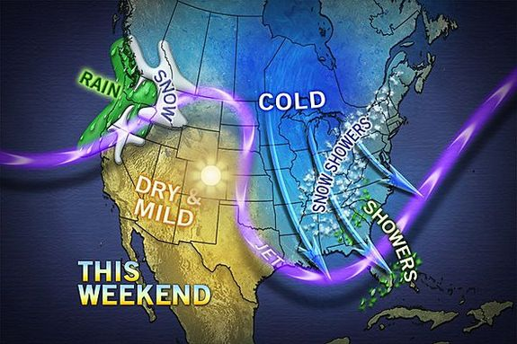
For the weekend of March 1, 2013, the jet stream allowed warm air to push into the Rockies, while cold air brought snow and rain to the eastern half of the United States. Credit: AccuWeather.com
Jet Streams and the weather
Jets streams play a key role in determining the weather, because they usually separate colder air and warmer air. Jet streams push air masses around, moving weather systems to new areas and even causing them to stall if they have moved too far away. In the United States, jet streams cause weather to flow from West to East.
While jet streams are one factor used in predicting weather, jet streams don’t follow a straight path. This is why weather forecasting by meteorologists is not always correct.
Climatologists say that changes in the jet streams are closely tied to global warming, because there is a great deal of evidence that the North and South poles are warming faster than the remainder of the planet. When the jets streams are warmer, their ups and downs become more extreme, bringing different types of weather to areas that are not accustomed to climate variations. If the jet stream dips south, for example, it takes the colder air masses with it.

