Fronts:
The Earth has 4 major _________ _____________, two ____________ ones and two ______________ ones. When those air masses _____________ into each other, the place where they meet is called a ___________________.
Fronts are responsible for all kinds of _________________, like ___________ and ______________.
A front is a __________________ created when two _________________ _________________ meet. Fronts are named for the air mass that is _____________________.
Cold Front:
Cold, _____________ air moves in and ____________ warm air out of the way
Cold fronts ________________ very quickly and bring ______________ periods of rain/_______________
_________________ temperatures are _________________ the front
Symbol- the ___________________ of the arrows points ____________ the direction the front is ________________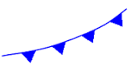
Warm Front:
Warm air moves up the cold front as it slowly ______________ and ________________ the cold air
Warm fronts move ________________, and bring many days of ___________________ precipitation
____________________ temperatures are behind the front
Symbol- direction of “_________________ _________________” is the direction the front is moving
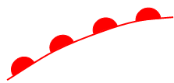
Stationary Front:
Created when _____________ and _____________ masses meet but neither one has enough ____________ to move the other out of the way
The _______________ ________________ in the warm air ___________________ into rain, fog, snow, and _____________________.
Can bring many days of _______________________.
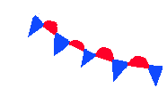
Occluded Front:
Is created when a _______________ air mass is caught between two ________________ air masses
The two ________________ cooler air masses cut off the _______________ air mass from the ground
As the warm air mass ________________, it may turn cloudy, _______________, or _______________.
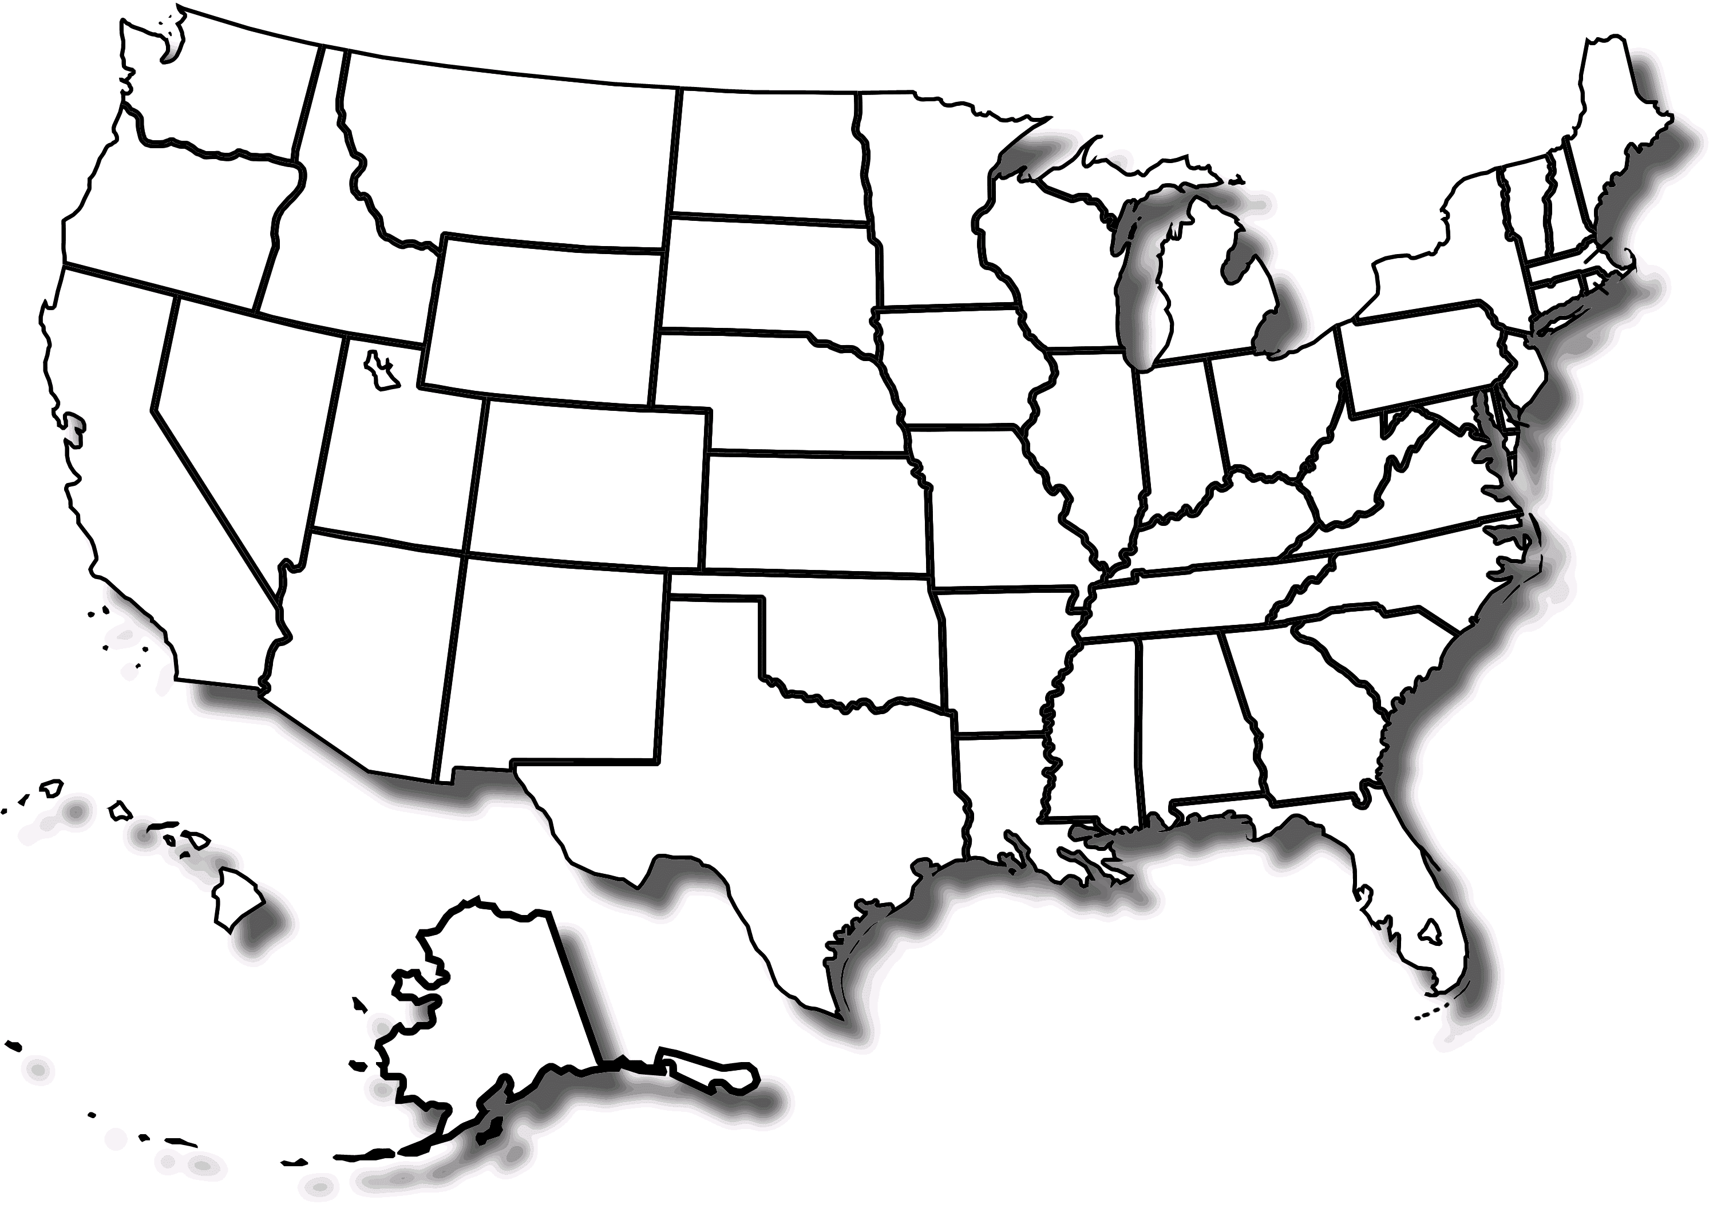
On the map above, draw two cold fronts, two warm fronts, and a stationary front, using the correct colors.
Describe the weather that will occur as each front moves into an area:
Cold front:
Warm front:
Stationary front:

