Skeletal System
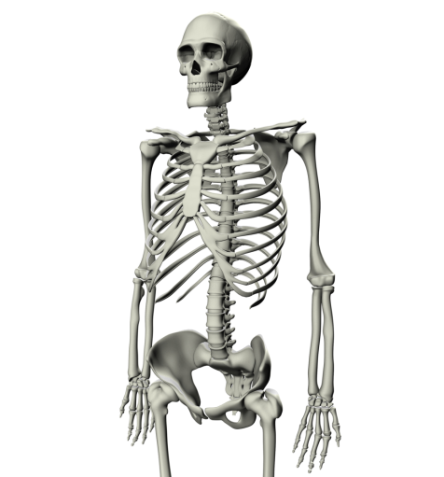
What is the purpose?
- Assists your body with ________________________________________

What are the parts and their purpose?
- ____________________
  - The __________ of your skeleton keep us from being a jello-like blob
- ____________________
  - Rib cage protects the ______________________
  - Skull protects the _________________
  - Spine protects the _______________________
- ____________________
  - Bones connect to one another at our _____________________
  - Ex: elbow, wrist, neck, ankle…
  - Bones depend on working with the _______________ in order to move; one ____________ move without the other!
  - Muscles are connected to bones by tissues called ______________________

What can go wrong?
- ___________________
  - bones loose calcium and become brittle; common among older women
- ___________________
  - attacks _____________ and the surrounding tissue causing ____________________ with movement.

How does it work with other body systems?
- ______________________: muscles are connected to bones which allow them to move
- ______________________: inside of your bone marrow is where red blood cells are made

Muscular System
What is the purpose?
- Works with the skeletal system to allow ______________________
- Each muscle is made up of individual muscle ______________; each fiber is one long, stretchy ___________________
- Move by a series of _____________________ (tightening) and ___________________
- Muscles work in _____________________
- Muscles connect to bones by tissues called ______________________

What are the parts and their purpose?
- ___________________________: you have control
- ___________________________: they move automatically
- Three types
  - __________________: voluntary muscles connected to your bones
  - __________________: involuntary muscle, found in your heart
  - __________________: involuntary muscle, found in your digestive system

What can go wrong?
- __________________________: causes weakness and loss of muscle mass
- __________________________: syndrome in which a person has long term, body wide pain and tenderness in the joints, muscles, tendons, and other soft tissues
- _________________: stretching or tearing of a ligament (tissues that hold bones together); the most common muscle disorder

How does it work with other body systems?
- _________________________: muscle connects to bones to help it move
- _________________________: nerves tell your muscles how and when to move
- _________________________: blood vessels go throughout your muscles to help give them nutrients/oxygen and take away waste; makes up your heart
- _________________________: muscles line your digestive tract

Circulatory System
What is the purpose?
- To carry _______________ rich blood around the body and deliver it to the ____________ _____________________
- To carry _______________ around the body and deliver it to the ______________________
- To pick up ______________ from muscles and organs and deliver it to the ____________ ____________________ for excretion
What are the parts and their purpose?
- Heart
  - A ___________________ that pumps _____________________ throughout your body
  - Made of ___________________ muscle
  - Located in the center of your chest _________________________________
  - Protected by your _______________________________________
- Blood vessels
  - ________________________ that _______________________ around your body
  - The three types are ____________________________________________
- Arteries
  - _________________________________ from the heart
  - Blood is full of ____________________________
- Capillaries
  - ________________________________________
  - Found in the __________________________________
  - Where ____________________________________ and ___________________________
  - __________________________ of these tubes are so ________________ that ___________________can pass right through
- Veins
  - ______________________________________ the heart
  - Blood is full of ___________________________
What can go wrong?
- _______________________________: blood vessels that go around the heart get blocked; heart muscle tissue dies; heart attack results
- _________________________: high fat diet results in arteries becoming hard; higher blood pressure results; heart and kidney damage can follow
- _________________________: inner lining of heart swells/becomes inflamed; some antibiotics can treat

How does it work with other body systems?
- ___________________________: blood passes through the lungs in order to pick up fresh oxygen or drop off carbon dioxide
- ___________________________: arteries carry oxygen and nutrients to the muscles; veins carry carbon dioxide and other waste away from the muscles
- ___________________________: red blood cells are made in bone marrow, which can be found inside bones
- ___________________________: blood vessels run through the kidneys so they can be filtered of waste material

Respiratory System
What is the purpose?
- To bring ______________________________ into the body (inhale)
- To get rid of __________________________ (exhale)
- Part of the “_____________________”
- This is a collection of body systems which all help to ____________________________ from the body
What are the parts and their purpose?
- Your respiratory system looks like an __________________ _______________________
- _________________________
- ______________________: where your _________________ can be found
- __________________: also known as the “____________”, runs down your throat
- __________________: two lobes which are made up of many smaller parts; lungs are not hollow!
- _____________________: the __________________ at the bottom of your lungs which cause you to breathe; moves down and contracts to expand lungs (inhale)
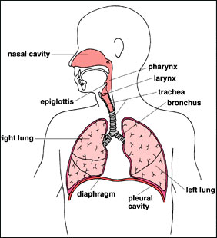
- Lungs
  - ___________________: two tubes which lead into the left and right side of your lungs
  - ______________________: the smaller and smaller tubes which branch off of the bronchi
  - ______________________: very _______________________, the end of the lungs, touching very tiny capillaries, ___________________________ from the alveoli into the capillaries, ____________________________ from the capillaries into the alveoli
What can go wrong?
- _______________________: a genetic condition which affects cells that produce mucus, sweat, and digestive juices; causes cells in the lungs to produce too much mucus; blocks breathing passages and traps harmful bacteria in the lungs
- _______________________: bronchioles in the lungs constrict (tighten) and inflame (swell up) making breathing difficult
- _______________________: damages the alveoli in lungs making it difficult to breathe; prevents old air filled with waste from exiting the body efficiently
How does it work with other body systems?
- ___________________________: a muscle called the _________________________ contracts and relaxes allowing lungs to ______________________________; provides the fresh oxygen needed for muscles to function; provides an out for waste carbon dioxide
- ___________________________: the circulatory system ____________________________ _____________________________ which is ___________________________________ by the respiratory system

Digestive System
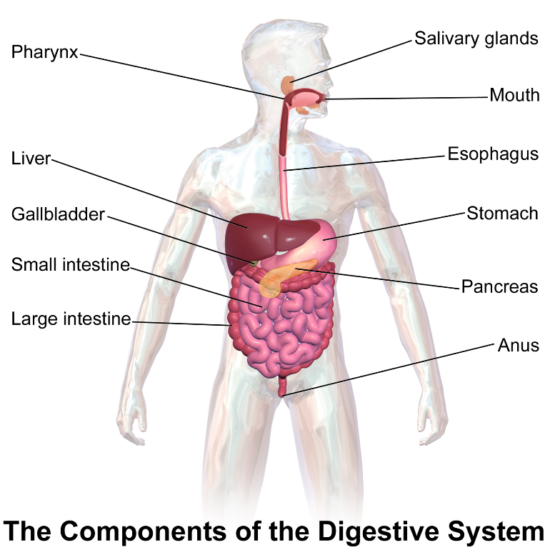
What is the purpose?
- To _______________________________________ into its _____________________
- To __________________________________________ into the blood stream
- To _____________________________ from your food
Two types of digestion
- _____________________________: food is mashed and physically broken down
- _____________________________: chemicals are added to food to chemically break them down
What are the parts and their purpose?
- Mouth
  - ______________________________________ and break down food
  - _________________________________ begins to break down starches into sugars
- Esophagus
  - Tube that ___________________________ down from your mouth to your stomach
  - Lined with ________________________
- Stomach
  - __________________________________ and mixes up food
  - _______________________________ breaks down food further
  - Lined with ______________________________
- Small Intestine
  - Lined with _________________________________ called villi
  - _________________________________ through the walls of the villi and into the ________________________ of the circulatory system
- Large Intestine
  - ____________________________________________
- Colon
  - Last section of intestines
  - _________________________________

- Food travels through the intestines in the following order: ________________, _________________, stomach, small intestine, ____________________, ________________

- There are organs that assist the digestive system which the food does not physically pass through
  - _____________________: produces insulin, assists the small intestine absorb nutrients
  - _____________________: assists in the digestion of fat
  - _____________________: no known use in the body
What can go wrong?
- _________________: caused by a virus, bacteria, or indigestion; the large intestine does not properly absorb enough water causing runny stool; dehydration can result from loss of water
- ______________________________: the body cannot break down the sugar lactase; causes diarrhea,
- _____________________: the body cannot digest the gluten protein; causes pain and cramping in the small intestine

How does it work with other body systems?
- __________________________: once nutrients are broken down into small pieces they are carried throughout the body in the circulatory system
- __________________________: nutrients broken down are supplied to the muscles to give them energy

Urinary System
What is the purpose?
- Filter _______________________________________________________ out of the blood
- _______________________________________ from those waste materials
- ________________________________________________________________________________

What are the parts and their purpose?
- Kidneys: blood vessels travel through the kidneys; kidneys _________________________ and keep the good nutrients in the blood; _________________________
- Ureters: two thin tubes which ____________________________________________________ __________________________________
- Bladder: ______________________________ until it is ready for excretion; lined with __________________________________
- _________________________: tube which the urine travels through to get from the bladder to the outside of the body

What can go wrong?
- ________________________: calcium separates from the urine and crystallizes; can cause a round or jagged piece to become stuck in the kidney, ureters or urethra
- ________________________________: temporary or permanent damage to the kidneys that result in loss of normal kidney function; this leaves waste in the blood and can cause damaged to other organ systems in the body

How does it work with other body systems?
- ___________________________: circulatory system sends blood to the kidneys so they can filter waste out of the blood stream
- ___________________________________: all organ systems would fail if fresh, clean blood was not supplied to them

Nervous System
What is the purpose?
- Interpret the ___________________________
- Sight, _______________, smell, __________________, touch
- ________________________________ to the outside environment
- ________________: a change in the environment that an organism reacts to (Ex: a loud noise)
- _________________: the reaction to the stimulus (Ex: you jump)
What are the parts and their purpose?
- Central nervous system:
  - Brain: contains 100 billion nerve cells, called neurons; ______________________ _____________________ (ex: walking, thinking) and involuntary behaviors (ex: heartbeat, blood pressure, posture)
  - Spinal Cord: the _______________________________________ from the brain to the nerves throughout the body
- Peripheral nervous system:
  - Nerves: nerves that leave the spinal cord and reach to ____________ of the body
- Autonomic nervous system
  - Sounds like _______________________
  - Controls the ________________, smooth muscles in the _____________________, and glands of the ________________________
  - Two main functions is to ___________________________ and conserve/store energy
  - Different functions are controlled by different structures
  - Cerebellum: __________________________________
  - Brain Stem: _____________________________
- Voluntary nervous system
  - ____________________________
What can go wrong?
- ______________________________: impacts mental functions, such as memory
- ___________________: abnormal electrical discharges from brain cells cause seizures
- _______________: the protective lining of the nerves is attacked by the immune system
- Amyotrophic lateral sclerosis (ALS): nervous system damage leads to weakened muscles; also called _________________________________
How does it work with other body systems?
- _____________________: voluntary nervous system controls muscle movement by sending electrical impulses through neurons
- _____________________: autonomic nervous system controls heart rate in the brain stem
- ______________________: autonomic nervous system controls breathing in the brain stem
- ______________________: autonomic nervous system controls movement of smooth muscle in the digestive tract
Endocrine System
What is the purpose?
- A collection of ____________________ which produce _______________________
- Regulates ___________________________________, metabolism, tissue function, sexual function, _______________________, sleep, and mood
What are the parts?
______________, ______________, _____________, ______________, ______________, ___________
What can go wrong?
- __________________________: the body does not break down glucose efficiently due to lack of insulin production
- __________________________: when the thyroid under functions; causes drops in body temperature and metabolism; body functions can slow or stop
Immune System
What is the purpose?
- to __________________________________ or other potentially harmful foreign bodies
  - _____________________ = anything that is not supposed to be in your body
What are the parts and their purpose?
- Lymph nodes: produce and store ________________________
- Spleen: contains white blood cells, regulates the amount of blood in the body, breaks down old blood cells
- White blood cells: lymphocytes and leukocytes; _________________________________ invading viruses and bacteria within the body
What can go wrong?
- ________________: when the body overreacts to a foreign body, called an “allergen”
- ___________________________: when the immune system works too much; attacks the organism’s own body tissues; Rheumatoid arthritis, lupus, multiple sclerosis, psoriasis
  - You would see an _________________________ if you had any of these conditions.
B-Cells:
- A _______________ blood cell that protects you from future invasions
- Patrols the ______________ and _____________________ systems looking for trouble
- Highlights dangerous _________________ with markers called antibodies
T-Cells:
- Another _____________ blood cell that works in the immune system.
- Trained to kill _____________________
- Disease of the T-cells: HIV (AIDS) attacks them

How does it work with other body systems?
- _________________________: produces white blood cells
- _________________________: helps to defend all body systems from foreign bodies

