Parts of a Cell
All living things are made of cells. Each cell has certain organelles that have a certain function, or purpose for the cell. Plants are made up of cells that help them form their structure while also helping them make their own food through photosynthesis. Plant cells have a cell wall that both protects the cell and forms its structure. Plant cells also have chloroplasts that contain chlorophyll that is used to make food (energy) for the cell.
Animals (humans included) are made up of cells, too. Animal cells have a cell membrane that forms the outer boundary of the cell. It only allows certain materials into and out of the cell.
All cells contain cytoplasm which is a gel-like material inside the cell. It contains water and nutrients needed by the cell.
All cells have a nucleus that acts like the control center for the cell. Think of the nucleus as the ‘director’ of the cell: it directs all the activity and contains all the information needed for the cell to function. The nucleus has a nuclear membrane that surrounds the nucleus and protects it.
All cells also have a mitochondria which breaks down food and releases it as energy for the cell. Think of the mitochondria as the ‘muscle’ of the cell.
All cells also have vacuoles which act as a storage center for the cell. They can store extra energy (food), water, and any waste materials not needed by the cell right away.
All these parts of the cell (organelles) have a certain function, meaning its role or purpose for being in the cell.
Plant versus Animal Cells
Put a checkmark(s) if the organelle is in plant cells, animal cells, or both.
Organelle | Plants | Animals
Cell membrane
Cell Wall
Cytoplasm
Mitochondria
Vacuole
Chloroplasts
Nucleus
Nuclear Membrane

How are the cell wall and the cell membrane alike?

How are chloroplasts and mitochondria alike?

How are the nuclear membrane and the cell membrane alike?

What do you think would happen if human cells had cell walls?
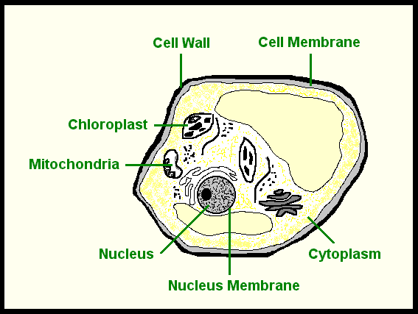
What type of cell is this? How do you know?

Describe the function of each of these organelles:
Nucleus:
Cytoplasm:
Chloroplast:
Cell Wall:
Mitochondria:
The Cell as a School
The cell wall acts like the brick wall surrounding our school; it provides structure and protects the people inside.
The cell membrane is like the doors at our school; they allow certain items (people) in and out of the school.
The nucleus acts like Ms. Faison; she directs all activity within the school just like the nucleus directs activity in the cell.
The nuclear membrane is like the main office at our school; the front office staff lets certain people in while not allowing others into see Ms. Faison.
The cytoplasm is like the floor of the school; it is where all the activity takes place.
The chloroplasts are like the lunch workers at our school; they give us energy by feeding us like the chloroplasts give plant cells energy in form of glucose.
The mitochondria is like the students at our school; they provide all the endless energy.
The vacuoles in cells are like storage closets in our school; they store materials for usage at another time.
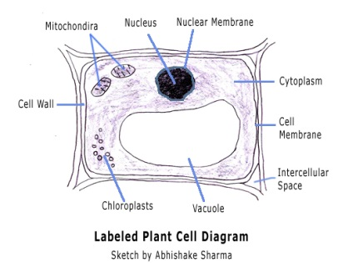
Parts of a Cell
Fill in the blanks in the following chart:
Organelle | Function | Analogy to our school
Cytoplasm
 | Storage area for the cell
Cell Wall
 |  | Students providing energy
 | Contains chlorophyll that is used to make food for the cell
 |  | Mr. Batchelor (our principal)
 | Forms outer boundary of cell; only allows certain materials to move into or out of the cell
Nuclear Membrane

Remember, an analogy is something used to help you remember key concepts of a lesson by having you compare it to something familiar. Will this analogy between the cell and our school help you remember?
Parts of a Cell (cont.)
Now, I would like you to come up with your own analogy for the cell and its organelles. Think about a factory, mall, city, or anything else that has these particular functions. I have started the chart for you:
What analogy are you going to use? __________________________________
Organelle | Function | Your own analogy
Cell Membrane

Cytoplasm

Nucleus

Nuclear Membrane

Mitochondria

Vacuole

Cell Wall

Chloroplast

