Plotting and Graphing Lesson
Speed:
Definition: the __________ of ____________ (how fast motion happens). Speed is the _________ traveled in a given time.
Calculating Speed:
Speed = ______________/______________
Units: meters/second (m/s)
Miles/hour (mph)
Kilometers/hour (km/h)
Speed Triangle: 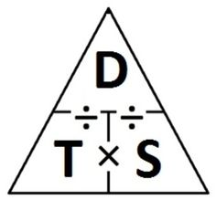
Distance vs. Time Graphs:
Shows how speed relates to ________________ and _________________.
Time is on the ____________________ axis (X-axis).
Distance is on the __________________ axis (Y-axis).
Interpreting Distance vs. Time Graphs:
As an object moves, the ____________________ it travels ___________________ with ________.
This can be seen as a ______________, or rising, line on the graph.
A ______________, ________________ line shows an interval of time where the speed is _______ meters per second (NO MOTION!!).
__________________ lines show intervals where the speed is _________________ (faster) than intervals with less steep lines.
The steepness, or _______________, of the line is calculated by _______________ the change in ______________ by the change in _____________ for that interval.

Your turn: You are returning home from your friend’s house:

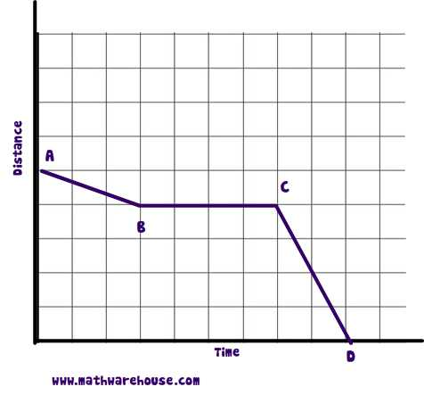
- Between what two points did you stop to pet a friendly dog? _________________________________________________________________
- Between what two points did you realize you were late and you began running? _________________________________________________________________
Below is a graph of Ms. Mettler running errands. She began at school, but realized she forgot her wallet, so had to return home.
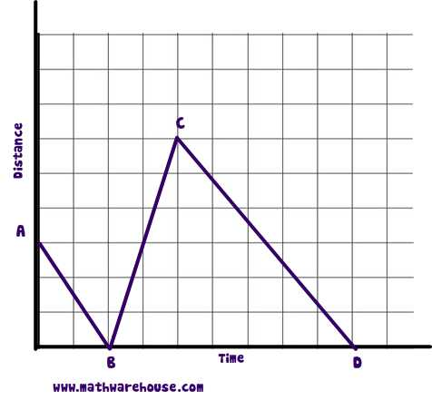
- At what point did Ms. Mettler first return home? _____________________________________________________________
- Compare Ms. Mettler’s speed at between points B,C and points C,D. _____________________________________________________________

