Speed, Velocity, and Acceleration
Speed:
Speed is a ___________ of how __________ something moves or the ________ it moves, in a given amount of time.
The __________ the speed an object has, the __________ it changes position!
Calculating speed:
To calculate speed, you need to know both ___________ and ___________!
d= distance; S= speed; t= time
Speed can be calculated by dividing the ___________ an object travels by the _________ it takes to cover the ________________.
The formula is: 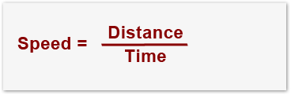
Units:
The standard unit for speed is m/s or ____________ per ____________
The most common speed unit we all know is ___________ per ________ or mph
Let’s try a few examples:
 | Distance | Time
Carlos | 100 m | 4 s
Lakeshia | 400 m | 8 s
Mark | 200 m | 10 s

Show work here!!

Finding distance and time:
If you know any two of the three variables (speed, distance, or time), you can find the third- simple algebra!! 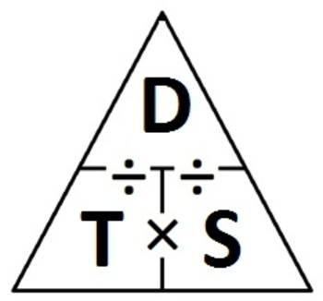
Speed = distance/time
Time = speed/distance
Distance = time X speed
Finding Distance:
Maria travels to Raleigh in 2 hours. Her average speed was 60 mph. What is the distance to Raleigh?
Finding Time:
Kailee runs 10 miles at an average speed of 5 mph. How long was her run?
Velocity:
Velocity is a __________ in a specific ____________. If you are walking east at a speed of three meters per second, you are describing ______________. A person walking _________ with a speed of three meters would have the same _________ as you do, but not the same _______________.
Acceleration:
Acceleration is the _________ at which __________ changes with time. It is a measure of how ___________ the ____________ is changing; if velocity does not change, there is no ______________.
When the acceleration is in the same _____________ as the object is moving, the ____________ of the object ___________ (the car speeds up)
When the acceleration is ____________ to the motion, the __________ of the object __________ (the car slows down). This is also called _______________.

