Weather Fronts

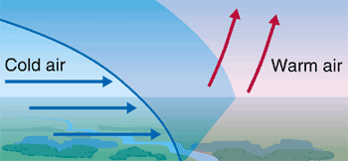
Cold Front
A cold weather front is defined as the change-over region where a cold air mass is replacing a warmer air mass. Cold weather fronts usually move from northwest to southeast. The air behind a cold front is colder and drier than the air in front. When a cold front passes through, temperatures can drop more than 15 degrees within an hour.

On a weather forecast map, a cold front is represented by a solid line with blue triangles along the front pointing towards the warmer air and in the direction of movement.

There is usually an obvious temperature change from one side of a cold front to the other. It has been known that temperatures east of a cold front could be approximately 55 degrees Fahrenheit while a short distance behind the cold front, the temperature can go down to 38 degrees. An abrupt temperature change over a short distance is a good indicator that a front is located somewhere in between.

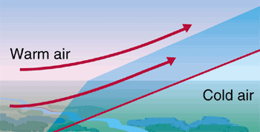
Warm Front
A warm weather front is defined as the change-over region where a warm air mass is replacing a cold air mass. Warm fronts usually move from southwest to northeast and the air behind a warm front is warmer and moister than the air ahead of it. When a warm front passes, the air becomes noticeably warmer and more humid than it was before.

On a weather forecast map, a warm front is represented by a solid line with red semicircles pointing towards the colder air and in the direction of movement.

Again, there is typically a noticeable temperature change from one side of the warm front to the other, much the same as a cold front.

If colder air is replacing warmer air, it is a cold front, if warmer air is replacing cold air, then it is a warm front.

Reading Questions
Answer these in complete sentences in your own sheet of paper.

- What is a cold front?
- In what direction do cold fronts normally move?
- What symbol is used to represent a cold front on a weather map?
- Give an example of the type of temperature change you could witness from a cold front.
- Draw what a cold front looks like. Be sure to use the words “cold air” and “warm air” as well as arrows to show the direction of movement.
- What is a warm front?
- In what direction do warm fronts normally move?
- What happens to the air as a warm front passes through?
- What symbol is used to represent a warm front on a weather map?
- Draw what a warm front looks like. Be sure to use the words “cold air” and “warm air” as well as arrows to show the direction of movement.
- “Colder air replacing warmer air” is what type of front?
- “Warmer air replacing colder air” is what type of front?

