Weather Review

Part 1: 7.E.1.1 Atmosphere
Directions: Answer the following questions.

- What gases make up the atmosphere (make sure to include percentages)?

- Which organisms began to change the composition of early atmosphere?

- What happens to temperature as you increase in elevation in the troposphere? Stratosphere?

- The presence of oxygen in our atmosphere makes what life process possible?

- Cold air is high pressure and warm air is low pressure. How would cold air on top of a mountain move?

Part 2: 7.E.1.2 Water Cycle

Directions: Sketch a diagram of the water cycle. Make sure to include evaporation, condensation, precipitation, run-off, and transpiration.

Directions: Explain what happens in each step of the water cycle.

Step in the water cycle | What happens in this step?
Evaporation
Transpiration
Condensation
Precipitation
Run-off

- What is fog?

- An abundance of sunshine and low humidity would make which step of the water cycle most likely?

- Energy from the ____________________ makes the water cycle possible.

Part 3: 7.E.1.3 Air Masses and Storms

Directions: Draw a picture of what happens when cold and warm water are mixed in a tank (Think about our lab).

- What do hurricanes need in order to stay energized?

- What kind of weather can you expect from a warm front?

- What information best helps meteorologists predict tornadoes?

- What has the most impact on regional climates?

Part 4: 7.E.1.4 Fronts and Clouds

Directions: Draw a picture of a cold, warm, and stationary front, as well as the symbol for each type of front and the weather it causes.

 | Illustration | Map Symbol | Weather caused
WARM FRONT
COLD FRONT
STATIONARY FRONT

Directions: Answer the following questions.

1. What happens when a warm air mass and a cooler air mass push against each other?

2. What type of front happens when a warm air mass pushes a cold air mass?

3. What type of weather can you expect from a low pressure system? What usually happens when there is a sharp decrease in air pressure?

Directions: Fill-in information about the three cloud types.

Cloud | Altitude  (high or low) | Weather it brings | Picture
Cumulus

Cirrus
Stratus

Part 5: 7.E.1.4 Weather Map Analysis

Directions: Answer the following questions about this weather map.

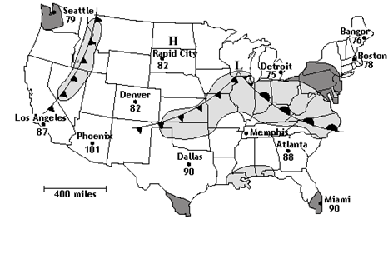
1. Where is there high and low pressure on this map?

2. How many cold fronts are on the map?

3. How many warm fronts are on the map?

4. Where is the temperature the greatest?

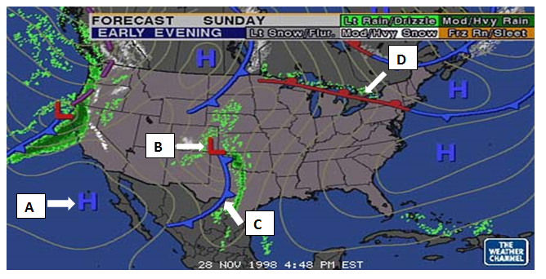
- What does symbol A stand for?
- What does symbol B stand for?
- What does symbol C stand for?
- What does symbol D stand for?
- What direction is the front by D going?
- What direction is the front by C going?
- What kind of weather would you predict by A?
- What kind of weather would you predict by B?
- What kind of weather would you predict by C?
- What kind of weather would you predict by D?

Part 6: 7.E.1.5 Global Winds

- In which direction do winds blow in the Northern Hemisphere due to the Coriolis Effect?

- What are the strong bands of wind in the upper troposphere called? How do they affect our weather?

- Explain what causes wind.

- Which factor causes surface ocean currents?

Part 7: 7.E.1.6 Human Impact on Weather
Directions: Explain the relationship between global warming, the greenhouse effect, carbon dioxide, and fossil fuels.

Directions: Label the following either as renewable or nonrenewable:

Source of Energy | Renewable or Nonrenewable
Solar

Coal

Petroleum

Nuclear

Wind

Directions: Answer the following questions.

1. How is the greenhouse effect both harmful and helpful?

2. Why do scientists recommend using renewable resources for energy?

3. What are chloroflourocarbons (CFC’s) and what do they do to the good ozone in the stratosphere?

4. What is the difference between the good and bad ozone? Make sure to include where they are in the atmosphere.

5. Why do we use fossil fuels (nonrenewable resources) rather than solar and nuclear energy?

6. If we continue to increase our usage of fossil fuels for the next decade, what will happen to the levels of carbon dioxide in our atmosphere? How will this affect our atmosphere?

